Best Fit (Memory Allocation)

DHIVYA SHREE K

230701079

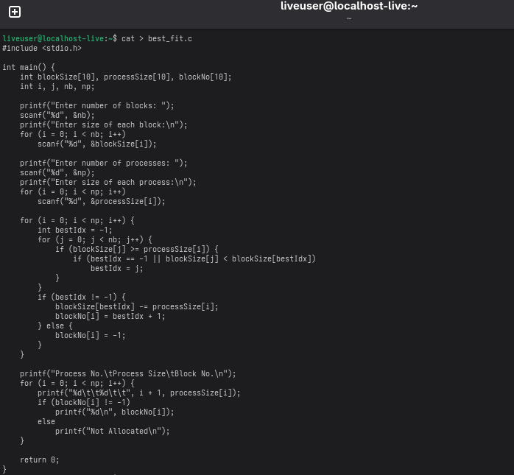

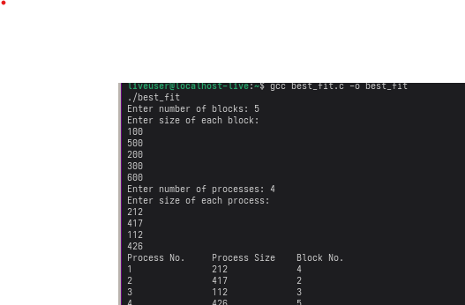

First Fit (Memory Allocation)

